For Release: | immediately
Image: | 2 x jpeg
 |  | September 12, 2018

Longer tool life and process reliability in thread forming operations
The EMUGE cold-forming tap InnoForm Steel-M sets new standards with its innovative geometry and coating.
Made of HSSE-PM, the Emuge InnoForm Steel-M is aimed at thread forming in medium strength steel materials with a tensile strength of 600-1,200 N/mm² or nodular cast iron and 350-500 N/mm². Its new geometry with more lubrication flutes and the optimized TiN coating result in excellent tool life and higher process reliability. Process reliability is also improved by the lower torque compared to predecessor tools, because the release of overload clutches can be prevented. Designed for through and blind-holes up to a thread depth of 3 x D, the taps are available in the two lead-in chamfer forms C and E, tolerance 6HX and optionally with internal coolant supply. They cover the metric threads from M3 to M36 and fine threads from M12 to M16, each with a pitch of 1.5.

About EMUGE-FRANKEN:
For nearly 100 years, the German company group EMUGE-FRANKEN has been one of the world`s leading manufacturers of precision tools for thread cutting, gauging, clamping and milling. With 1,800 employees, EMUGE-FRANKEN offers an innovative product program with 40,000 in-stock items and a multiple of that with customer-specific tools. The product range is focused on applications in the automotive industry, power plants, aerospace industry, medical technology as well as mechanical and plant engineering. As a system supplier for machining industry, EMUGE-FRANKEN has own branch offices or sales partners in 52 countries.

Press Contact:
Joerg Teichgraeber / Marketing Management
Joerg.Teichgraeber@emuge.de
Telephone +49 9123-186-555

EMUGE-Werk Richard Glimpel GmbH & Co. KG
Fabrik für Präzisionswerkzeuge
Nürnberger Straße 96-100, 91207 Lauf, Germany
Telephone +49 9123-186-0
www.emuge-franken.com

Images:

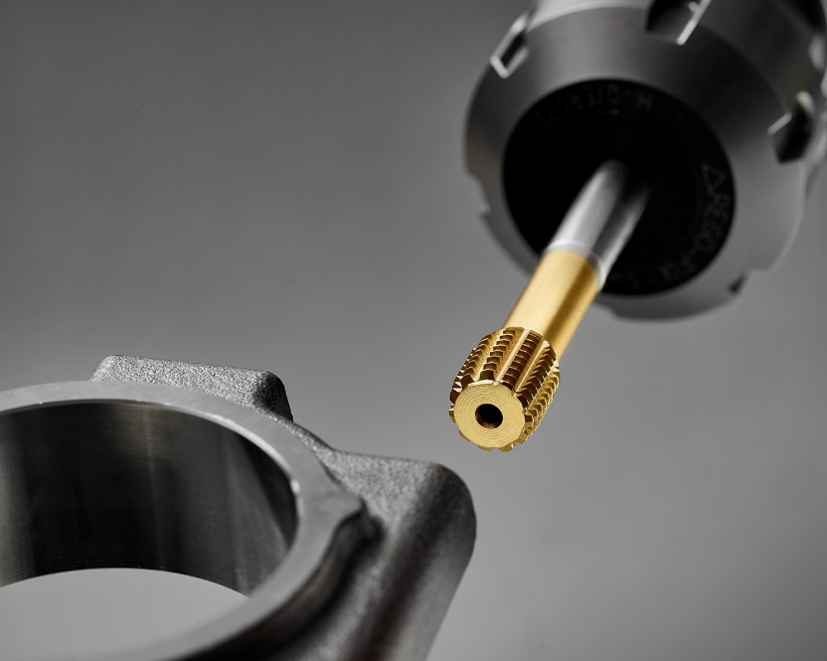
Image 1: The newly developed geometry is setting benchmarks for the process reliability.

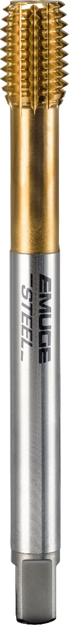
Image 2: The InnoForm Steel-M cold-forming taps cover threads from M3 to M36 as well as fine threads with M12 x 1.5 to M16 x 1.5.

